Configuring SAML SSO with OneLogin and EVERFI Foundry
The following document provides some tips and guidance on adding an App for EVERFI as a service provider in a OneLogin identity provider.

Adding an App
In OneLogin, add a connector (App).

In OneLogin, add an App. On the Find Applications page, search for SAML Test Connector (Advanced) and choose this one. This is a good App template because it contains nearly any property you might need to set. More details at: SAML Test Connector (Advanced) | OneLogin.

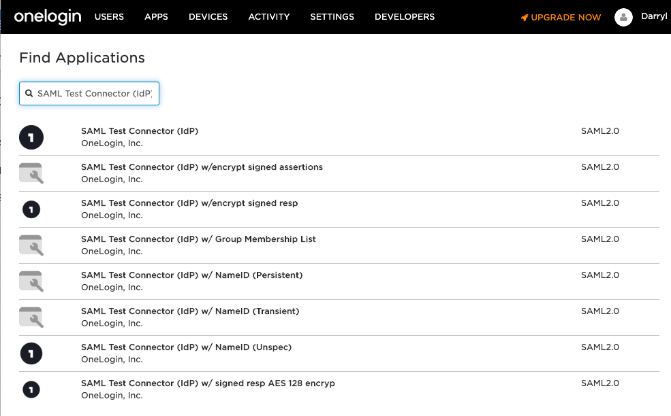

Give the App a name like EVERFI:
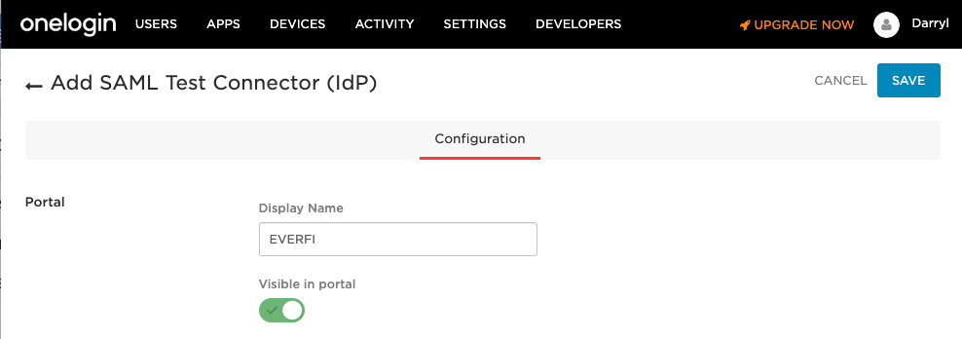
Choose the Visible in portal toggle as applicable. This template page (not shown in screenshot) also lets you add a description and icon.

Save the App

Configuration
Next, on the Configuration tab enter the following fields but use the specific URLs for your own organization. You can get those values from the EVERFI SAML Metadata that you download from Foundry.
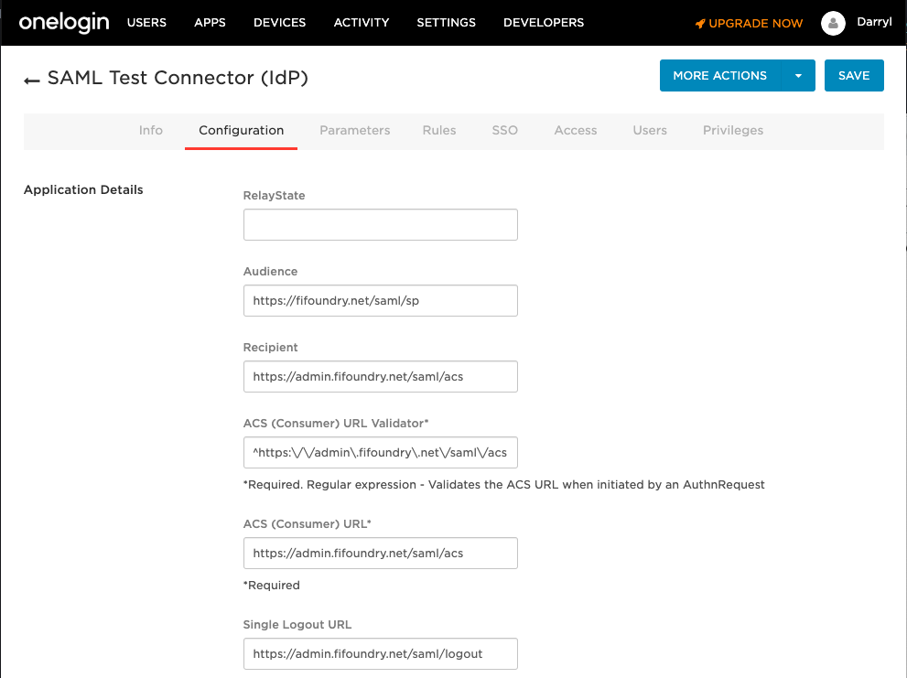
In the examples below, substitute org_slug with your actual organization slug that is in your Foundry SAML metadata file, or get these properties from the View Metadata feature in Foundry by navigating to Settings → Single Sign-on, then click View. If the entries in you metadata file do not have an org slug in the URL (which would be the case if you implemented SSO prior to early 2019), then omit it.

RelayState - leave blank

Audience - https://fifoundry.net/org_slug/saml/sp

Recipient - https://admin.fifoundry.net/org_slug/saml/acs

ACS (Consumer) URL Validator - ^https:\/\/admin\.fifoundry\.net\/org_slug\/saml\/acs

ACS (Consumer) URL - https://admin.fifoundry.net/org_slug/saml/acs

Single Logout URL - https://admin.fifoundry.net/org_slug/saml/logout

Parameters
On the Parameters tab, confirm the NameID property. For this OneLogin template, the NameID property defaults to email address. If you will provide a different property for NameID, then change the value.

If you are enabling user registration during SSO, then add additional parameters for first name, last name, and email address.

SSO
The default properties on the SSO tab are correct and do not need altering.

Access
If you wish to restrict the app to certain groups, then do so here.

Documentation Updates
Version | Date | Update
1.0 | 07/24/2019 | First version of document
1.1 | 9/9/2019 | Minor updates.

This table and the document name will be updated whenever significant changes are made to this document. This versioning is for the documentation itself, not for the actual software products.

